Linux is acts as interpreter.

“ ” – string

‘ ‘-string

` `-command

Variable:

1.global variable

2.local variable

3.special variable

Command line:

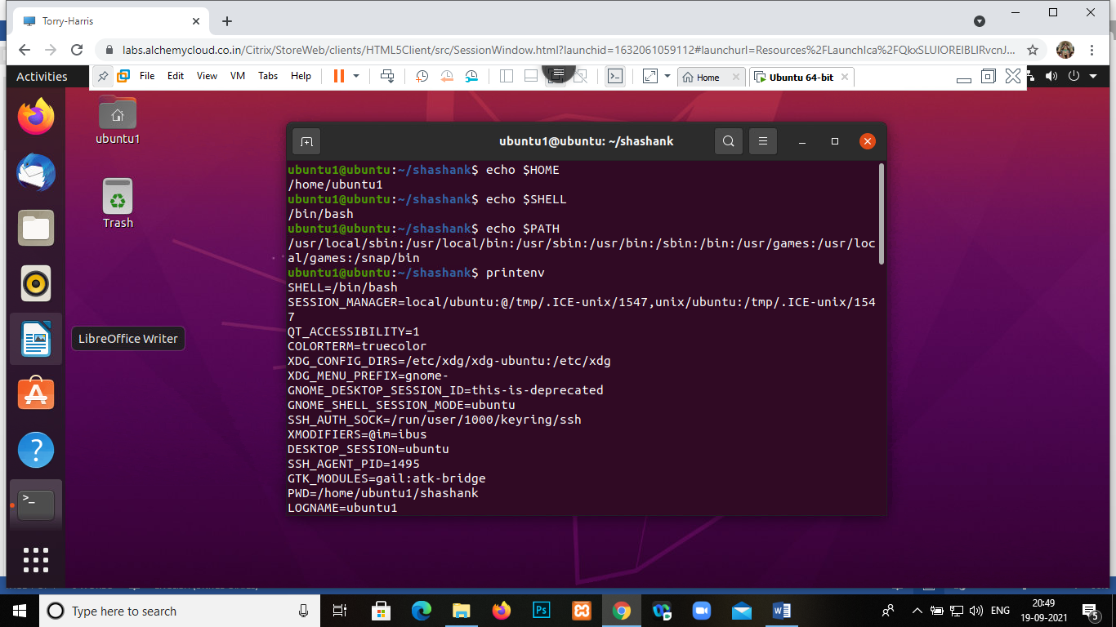

$-identifies as a variable

$$- process id

$0-name of the script

$#-number of command line arguments

$@/\*-all command line argument passed into script

$?-return code

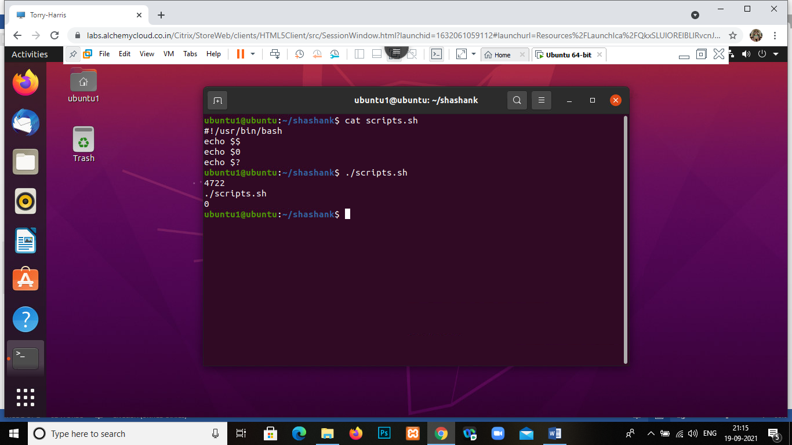

If condition:

If[condition]:

Then

Statement

Fi

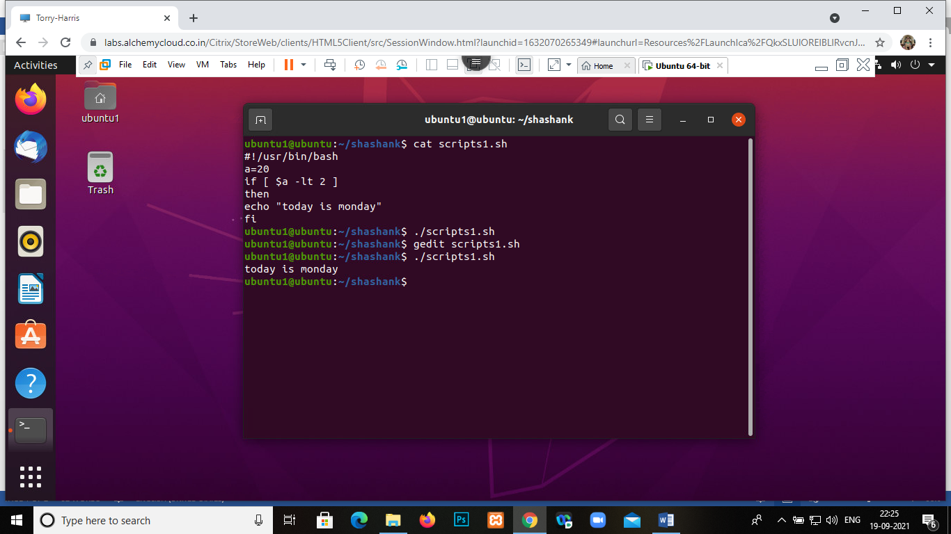

If else:

If[condition]

Then

Statement

Elif[condition]

Then

Statement

Else[condition]

Statement

Fi

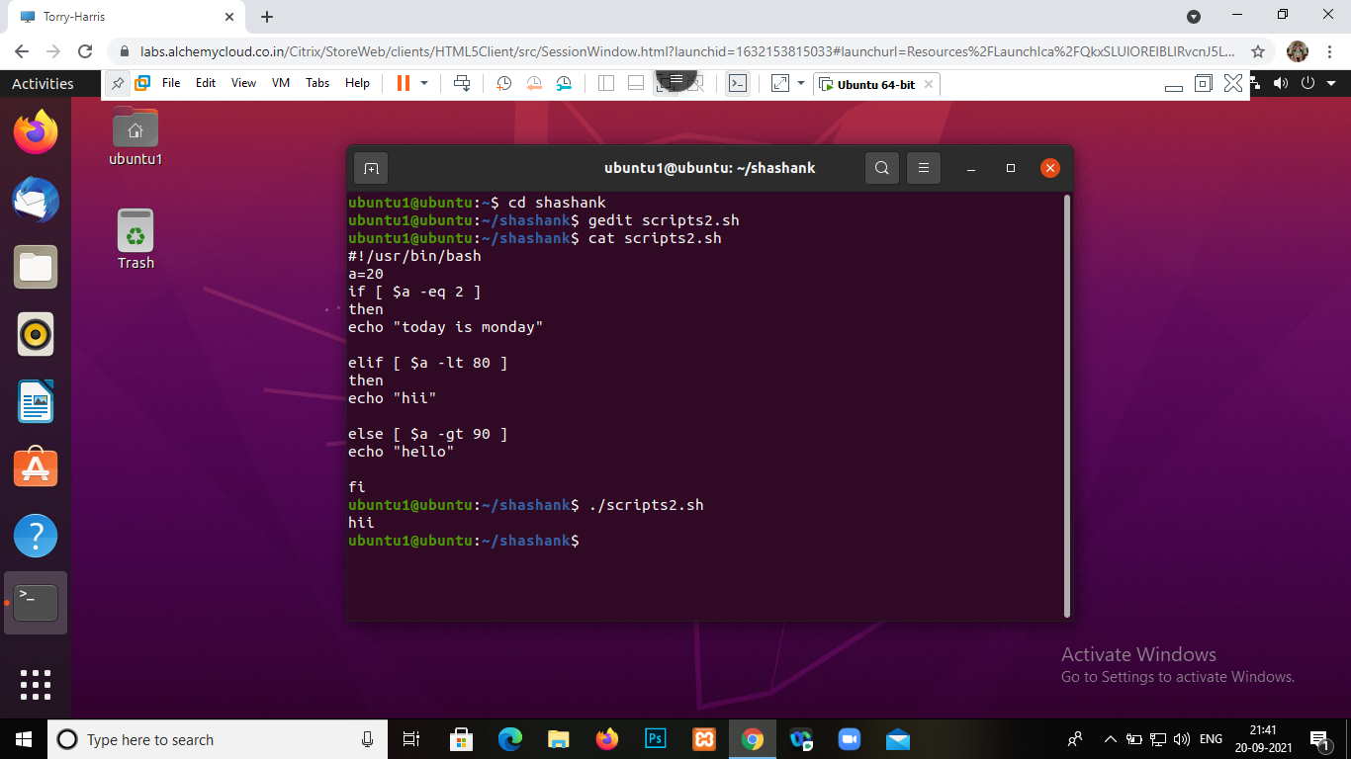

For statement:

For[condition]

Do

Command

Done

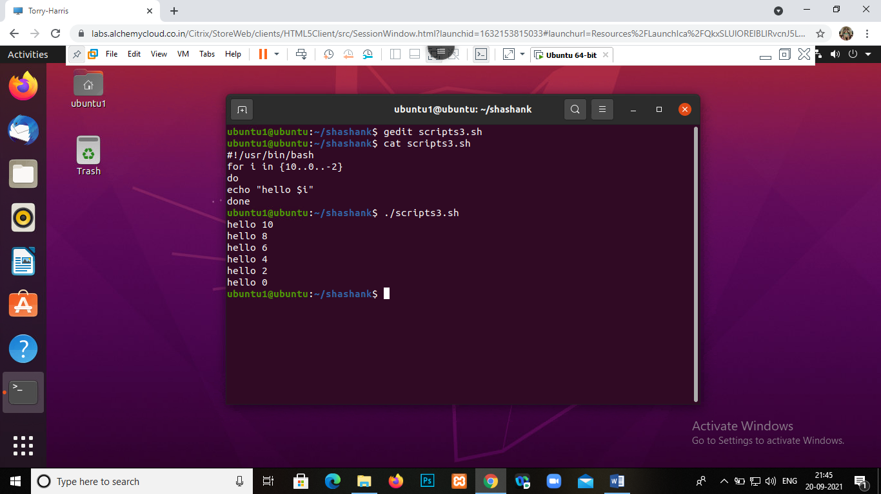

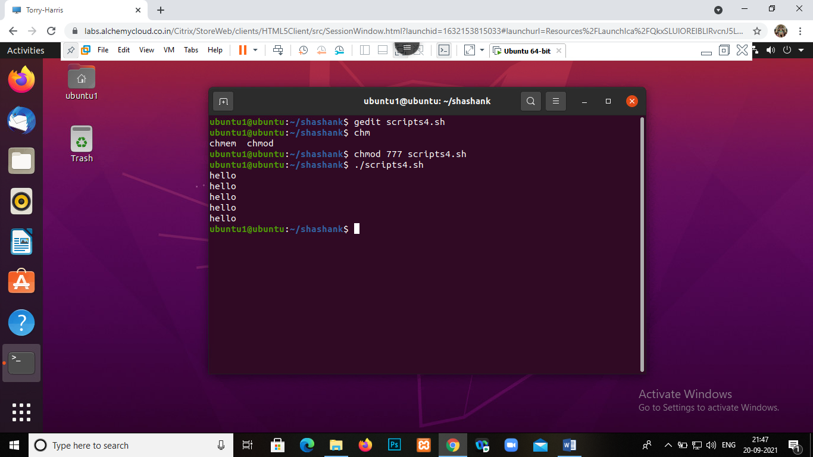

While condition:

While[condition]

Do

Command

Done

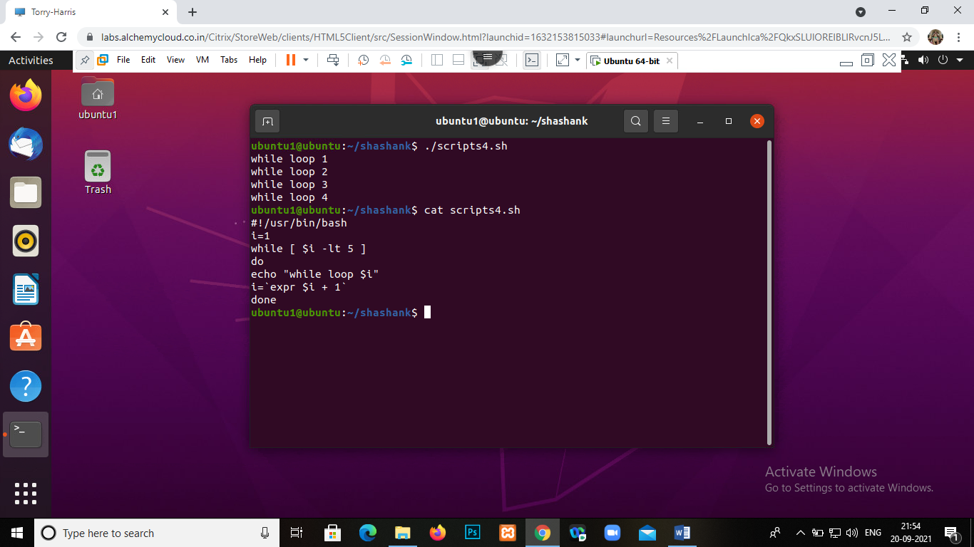

Until:

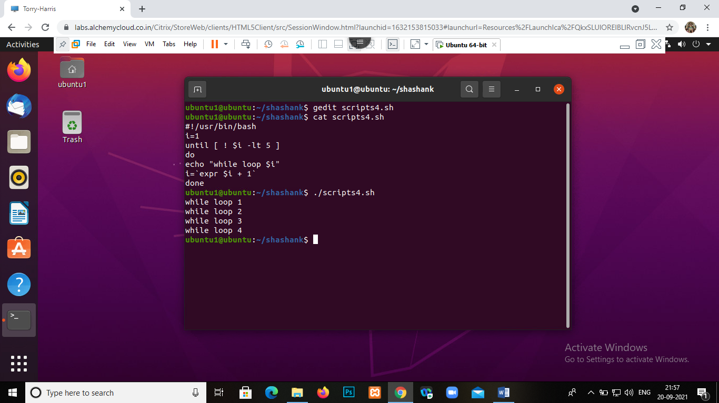

Function:

